**21GNP301L COMMUNITY CONNECT REPORT**

***Submitted by***

**RAMESHVAR A(RA2211004010323)**

***in partial fulfillment for the award of the degree***

***of***

**BACHELOR OF TECHNOLOGY**

in

**ELECTRONICS & COMMUNICATION ENGINEERING**

**DEPARTMENT OF ELECTRONICS AND COMMUNICATION ENGINEERING**

**SCHOOL OF ELECTRICAL AND ELECTRONICS ENGINEERING**

**COLLEGE OF ENGINEERING AND TECHNOLOG**



**­**

S.R.M. NAGAR, Kattankulathur, Chengalpattu District

**November 2024**



**SRM INSTITUTE OF SCIENCE AND TECHNOLOGY**

(Under Section 3 of UGC Act, 1956)

**BONAFIDE CERTIFICATE**

Certified to be the bonafide report of work done by “**RAMESHVAR A (RA2211004010323)” of B.Tech Electronics and Communication Engineering Degree Course in the** 21GNP301L Community Connect during the academic year 2024-25

|  |  |
| --- | --- |
| **SIGNATURE** | **SIGNATURE** |
| **Course In charge**  Dept. of Electronics &  Communication Engineering | **Academic Advisor**  Dept. of Electronics &  Communication Engineering |

**CERTIFICATE**



**SRM INSTITUTE OF SCIENCE AND TECHNOLOGY, KATTANKULATHUR**

**COLLEGE OF ENGINEERING AND TECHNOLOGY**

**SCHOOL OF ELECTRICAL AND ELECTRONICS ENGINEERING**

**DEPARTMENT OF ELECTRONICS AND COMMUNICATION ENGINEERING**

**21GNP301L COMMUNITY CONNECT**

**Academic Year 2024-25 5th semester**

**Community Connect Service Log Sheet**

Registration number:

Name of the student:

|  |  |  |  |  |
| --- | --- | --- | --- | --- |
| Date | Time | Service duration  (in hours) | Signature of student | Signature of Coordinator |
|  |  |  |  |  |
|  |  |  |  |  |
|  |  |  |  |  |
|  |  |  |  |  |
|  |  |  |  |  |
|  |  |  |  |  |
|  |  |  |  |  |
|  |  |  |  |  |
|  |  |  |  |  |
|  |  |  |  |  |
|  |  |  |  |  |
|  |  |  |  |  |
|  |  |  |  |  |
|  |  |  |  |  |
|  |  |  |  |  |
|  |  |  |  |  |
|  |  |  |  |  |
|  |  |  |  |  |
|  |  |  |  |  |
|  |  |  |  |  |
|  |  |  |  |  |
|  |  |  |  |  |
|  |  |  |  |  |

**OBJECTIVES OF THE COMMUNITY CONNECT**

The primary objective of this voluntary service, aimed at teaching badminton for students aims to foster physical fitness, skill development, and a supportive environment. Through regular practice, students improve their overall health, stamina, and motor skills while learning badminton fundamentals such as serving, footwork, and racket techniques. The program emphasizes not just individual growth but also teamwork, communication, and respect for others. Discipline is a core aspect, helping students balance sports with academics and manage their time effectively. As they master new skills, their self-confidence increases, enabling them to face challenges on and off the court. The program promotes healthy competition, teaching students to win gracefully and learn from losses. It also strengthens bonds among students, parents, and local organizations, building a sense of community and shared purpose. It equips students with physical, social, and life skills that benefit them beyond the court.

**TABLE OF CONTENTS**

|  |  |  |
| --- | --- | --- |
| **S. No** | **Content** | **Page No.** |
| **1** | **INTRODUCTION OF THE ORGANIZATION** |  |
| **2** | **WEEK-WISE REPORT** |  |
| **3** | **TANGIBLE LEARNING** |  |
| **4** | **STUDENT’S CONTRIBUTION** |  |
| **5** | **PHOTOS** |  |
| **6** | **CONCLUSION** |  |

**1.CHAPTER INTRODUCTION OF THE ORGANIZATION**

Organization Name : Smashbounce Pvt Ltd

Address : P N Ramamoorthy Rd, Kannammal Avenue, Valasaravakkam, Chennai

Pin code : 600087

Founded in 2013, Smashbounce is a private multidisciplinary sports company celebrating the spirit of sports in Chennai. They cultivate an active community of champions, sports professionals, passionate players, and dedicated fans, particularly around the beautiful game of Badminton. They are proud to be a leading chain of indoor sports arenas in the city.

**MISSION OF SMASHBOUNCE**

Promote Excellence in Badminton: To provide high-quality coaching and facilities that enable players to reach their full potential and excel in badminton.

Encourage Participation: To make badminton accessible to people of all ages and skill levels, promoting a healthy and active lifestyle.

**VISION OF SMASHBOUNCE**

Holistic Development: To develop not just skilled players but well-rounded individuals who exhibit sportsmanship, leadership, and integrity both on and off the court.

Sustainable Growth: To build a sustainable model that ensures the long-term success and expansion of the academy, benefiting future generations of players

**HOW DOES SMASHBOUNCE WORK?**

Typically operates with the goal of providing structured training and development for players of varying skill levels, from beginners to advanced players.

**MAIN SECTORS OF WORK**

* Structured Curriculum
* Individualized Coaching
* Fitness and Conditioning
* Progress Evaluation

**2.CHAPTER WEEK-WISE REPORT**

Week - 1 :

**DAY – 1 [31-05-2024]:**

**Introduction and Assessment**

**ACTIVITIES :**

* Initial assessment of players skills through drills and mini-games.
* Identified baseline skills and understanding of participants
* Established rapport and created a positive learning environment.

**DAY – 2 [ 01-06-2024 ] :**

**Technique Focus - Grip and Footwork**

**ACTIVITIES :**

* Detailed instruction on correct grip techniques.
* Footwork drills focusing on movement around the court.
* Practice sessions with feedback from coaches.
* Identified areas for individual improvement.

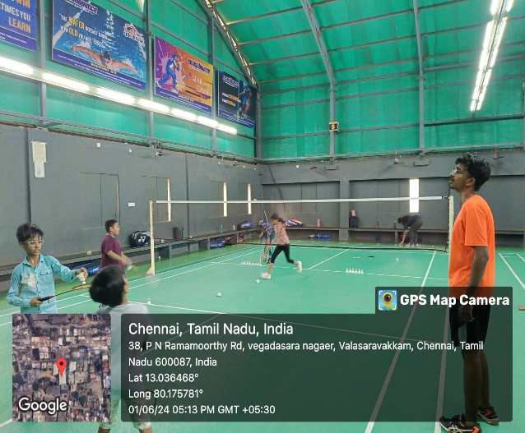

. 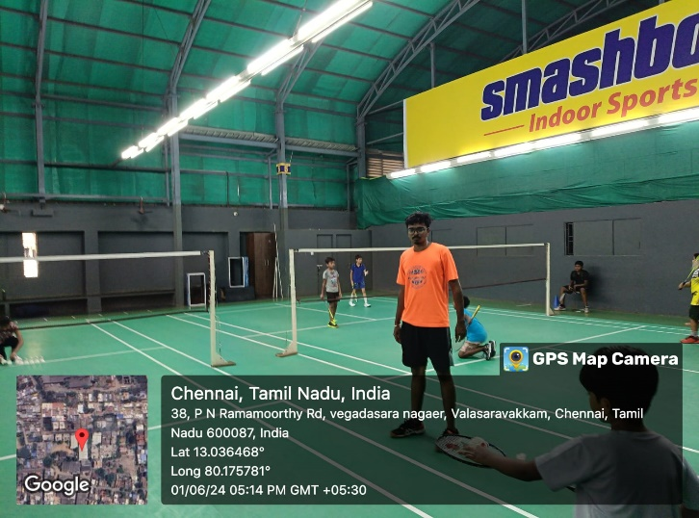

**Fig 1 : Week 1 Fig 2 : Week 1**

Number of hours spent : 8 hours

Week - 2 :

**DAY – 3 [ 04-06-2024 ] :**

**Stroke Techniques - Serve and Clear**

**ACTIVITIES :**

* Breakdown of serve techniques: short serve, flick serve, etc.
* Clear techniques: high clear, attacking clear, defensive clear.
* Drills to practice and refine these techniques.
* 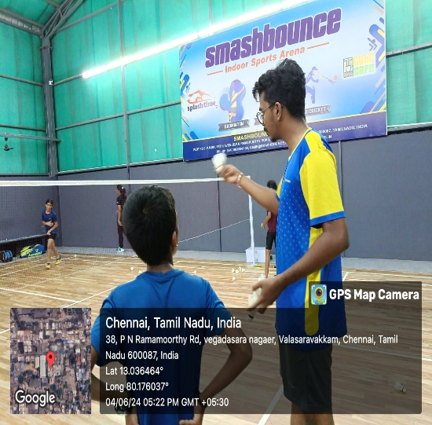Recognized the importance of stroke variety in gameplay.

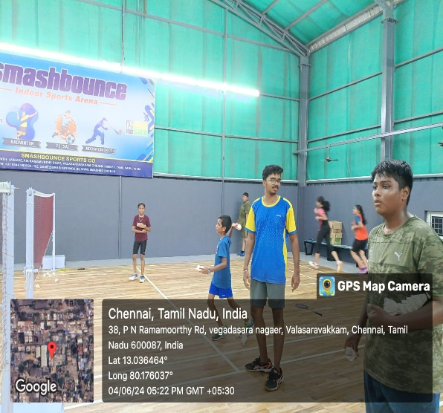

**Fig 3 : Week 2 Fig 4 : Week 2**

**DAY – 4 [ 07-06-2024 ] :**

**Strategy - Singles vs. Doubles Play**

**ACTIVITIES:**

* Understanding differences between singles and doubles strategies.
* Tactical drills focusing on positioning and shot selection.
* Application of strategies through simulated match play.
* Enhanced tactical awareness in both singles and doubles formats.

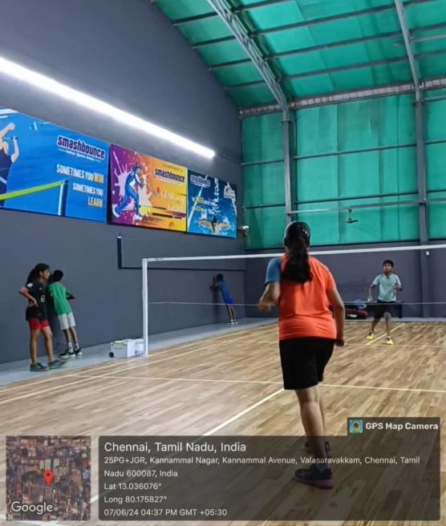

**Fig 5 : Week 2**

Number of hours spent : 8 hours

Week - 3 :

**DAY – 5 [ 12-06-2024 ] :**

**Advance endurance and agility**

**ACTIVITIES:**

* Warm-up and stretching
* Agility ladder drills around the court.
* Multi-directional movement practice.
* Quick reflex drills and sprints.

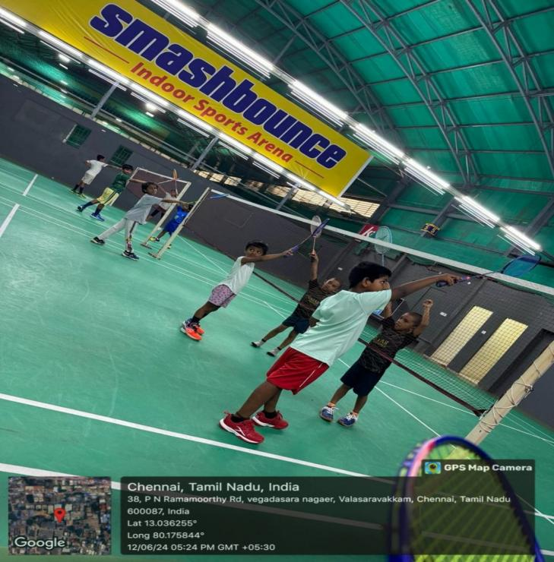

**Fig 6 : Week 3**

**DAY – 6 [ 15-06-2024 ] :**

**Mid-Program Review and Recovery**

**ACTIVITIES:**

* Warm-up and light stretching
* Review of progress and feedback session
* Recovery exercises (yoga, foam rolling)
* Warm down excercises

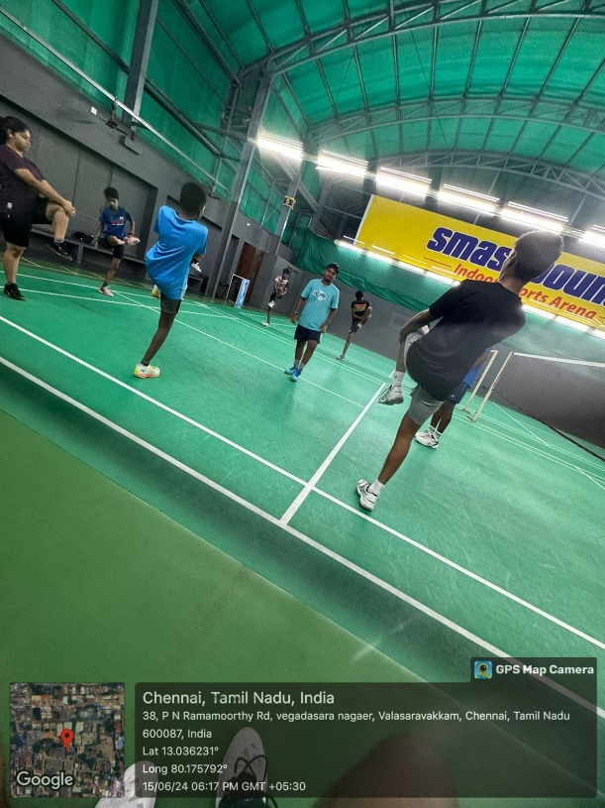

Fig 7 : Week 3

**DAY – 7 [ 21-06-2024 ] :**

**Advance conditioning and strengthening**

**ACTIVITIES:**

* High-intensity interval training
* Warm-up and conditioning exercises
* Enhanced endurance and stamina agility
* Multi-directional movement practice.
* Quick reflex drills and sprints.
* Warm down excercises

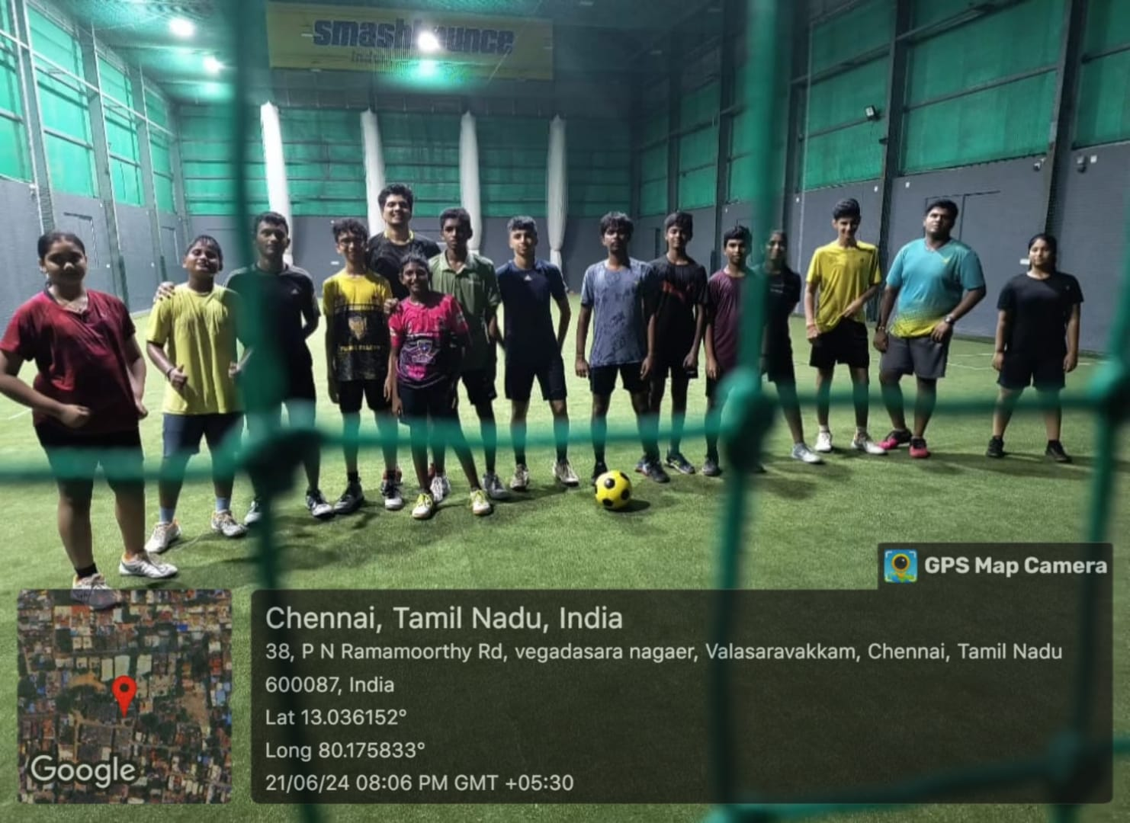

**Fig 8 : Week 3**

Number of hours spent : 12 hours

Week - 4 :

DAY – 8 [ 28-06-2024 ] :

**Stroke Development**

**ACTIVITIES:**

* Warm-up exercises.
* Forehand and backhand drills.
* Smash and drop shot practice.
* Rally simulations.

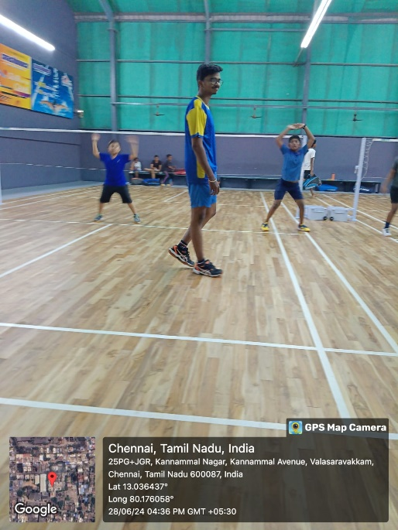

**sDAY – 9 [ 01-07-2024 ] :**

**Net play and drop shots**

**ACTIVITIES:**

* Warm-up with focus on wrist and finger flexibility.
* Instruction on shots net play techniques, including net kills and net lifts.
* Drills on executing and defending drop shots.
* Execution and defense of drop.

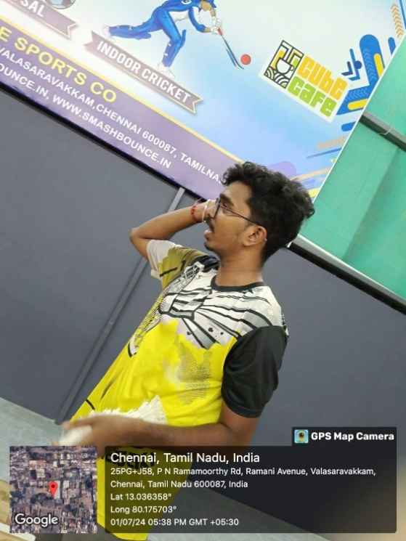

**Fig 10 : Week 4**

**DAY – 10 [ 02-07-2024 ] :**

**Smash and Clear**

**ACTIVITIES:**

* Warm-up emphasizing explosive movements.
* Instruction on techniques for powerful smashes and deep clears.
* Drills to practice smashes and clears under pressure.
* Control of clears to different areas of the court.
* Warm down excercises.
* Fun games

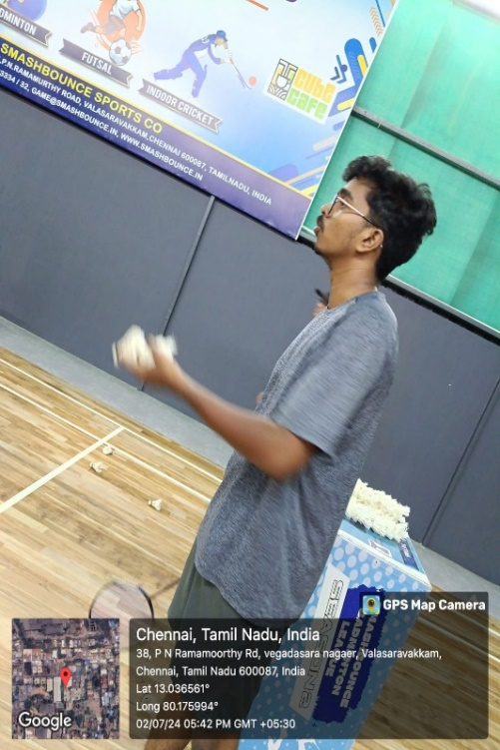

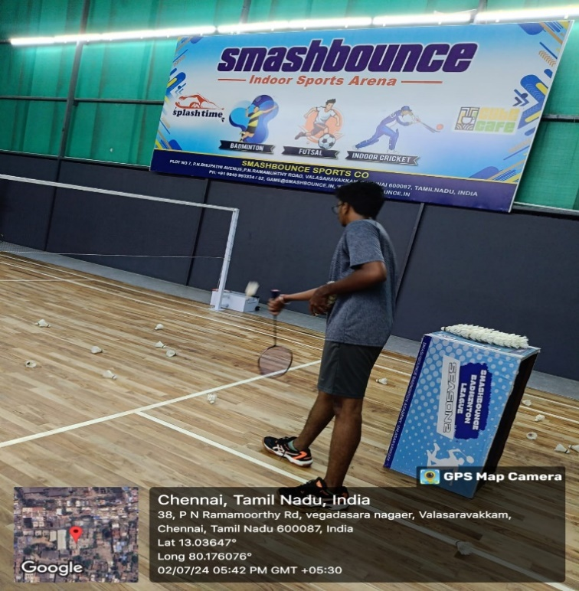

**Fig 11 : Week 4**  **Fig 12 : Week 4**

**Number of hours spent : 12 hours**

3. CHAPTER

TANGIBLE LEARNING

**Week 1: Fundamentals and Assessment**

**Objective**: Assess the skill level of players and reinforce fundamental techniques.

**Activities**:

* Warm-up routines focused on dynamic stretching and basic footwork drills.
* Technical drills for basic strokes (forehand, backhand, clear, and drop).
* Initial match-play assessment to identify player strengths and areas for improvement.

**Outcomes**:

* Players showed improvement in footwork alignment and basic stroke execution.
* Individual strengths and weaknesses were documented for tailored future training.

**Week 2: Footwork and Movement**

**Objective**: Enhance agility and effective court coverage.

**Activities**:

* Focused footwork drills (e.g., shadow practice, ladder drills).
* Simulated rally scenarios for applying proper movement patterns.
* Introduction to split-step technique for quicker reactions.

**Outcomes**:

* Improved players' speed and positioning on the court.
* Notable progress in executing defensive and offensive footwork

**Week 3: Shot Variety and Strategy**

**Objective:** Expand shot repertoire and introduce game strategy

**Activities**:

* Drills for advanced shots like smashes, net play, and deceptive strokes.
* Game-based training emphasizing placement and tactical awareness.
* Pairing players for doubles strategy practice focusing on rotation and communication.

**Outcomes**:

* Players exhibited better shot variety and increased confidence in their attacking and defensive shots.
* Enhanced understanding of shot selection and tactical planning in match situations.

**Week 4: Match Play and Competitive Analysis**

**Objective**: Implement learned techniques in competitive match play and provide feedback.

**Activities**:

* Round-robin matches to practice real-game scenarios.
* Video analysis sessions to review gameplay and identify strategic improvements.
* One-on-one feedback discussions focused on refining skills and mental preparedness.

**Outcomes**:

* Players showed noticeable improvement in match play, using enhanced footwork, shot variety, and strategy.
* Individualized feedback helped players identify personal areas to work on, contributing to a more tailored approach in future sessions.

**Overall Impact**:

Over the four weeks, players advanced from reinforcing fundamental techniques to incorporating complex strategies into their match play. The structured approach allowed for measurable improvements in both technical skills and tactical understanding, setting a strong foundation for future progress.

**4.CHAPTER**

**STUDENT’S CONTRIBUTION**

**Week 1:** **Engagement and Assessment**

**Contribution**:

* Players actively participated in warm-up and fundamental skill drills, showing enthusiasm and commitment.
* They provided feedback on their comfort levels with basic strokes, aiding in assessing their starting skill level.
* Demonstrated teamwork and support by helping each other during initial practice rounds and group activities.

**Week 2: Footwork and Movement**

**Contribution:**

* Students consistently attended sessions and worked diligently on footwork drills, demonstrating a clear focus on improving agility and movements.
* Players showed resilience by adapting to new techniques like the split-step and worked together to motivate each other through challenging drills.
* Some students took the initiative to practice outside of scheduled sessions, showing a proactive approach to enhancing their footwork.

**Week 3: Adaptability and Strategic Thinking**

**Contribution**:

* Players contributed by embracing more complex drills and applying new techniques such as smashes and deceptive shots.
* They shared insights during group strategy discussions, showing an eagerness to understand tactical elements of the game.
* In doubles practice, players demonstrated teamwork and improved communication, learning to rotate and position themselves effectively.

**Week 4: Competitive Spirit and Reflective Learning**

**Contribution**:

* Students brought high energy to match-play sessions, demonstrating a competitive spirit and willingness to implement learned skills.
* They were attentive and receptive during video analysis sessions, providing self-reflections on their gameplay and acknowledging areas for growth.
* Players actively engaged in feedback discussions, asking questions and showing a genuine interest in refining their techniques and strategies.

**Overall Contribution:**

Throughout the four weeks, students displayed dedication, adaptability, and a strong willingness to learn. Their active participation not only contributed to their individual progress but also fostered a collaborative and supportive training environment. Their commitment to practicing both within and outside of training sessions highlighted their desire for continuous improvement and contributed to the success of the coaching program.

5.CHAPTER

PHOTOS



















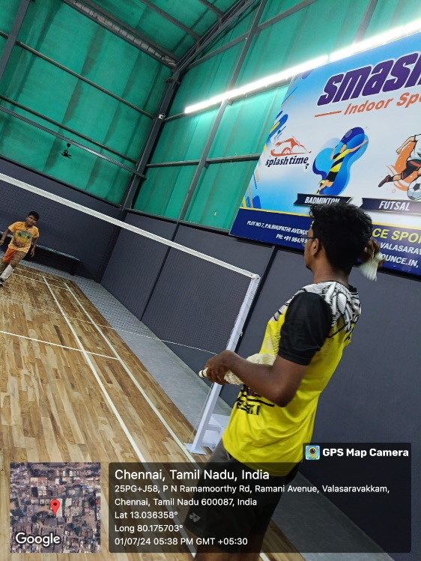



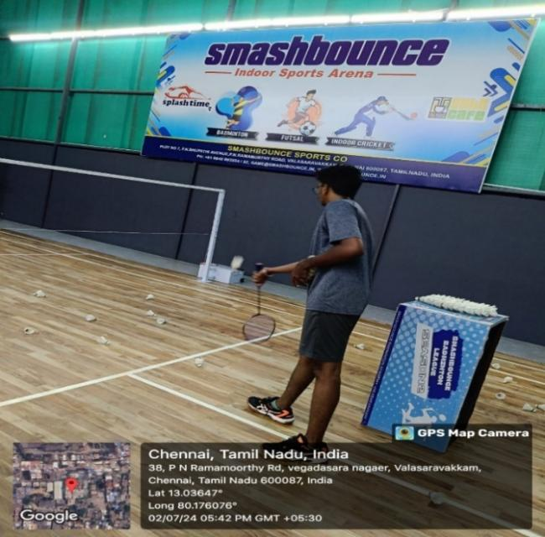

6. CHAPTER

CONCLUSION

Over the past 1 month, my coaching program has focused on enhancing essential badminton skills, techniques, and strategies. Through structured instruction and practical drills, I have seen significant progress in each participant's abilities and understanding of the game.

Players have improved their basic and advanced techniques, including serving, smashing, net play, and footwork.

Emphasis on singles and doubles strategies has enhanced players' positioning, shot selection, and tactical play.

The training sessions have boosted endurance, agility, and overall fitness. Focus on communication and teamwork has strengthened doubles partnerships.

Mock tournaments provided valuable match play experience, allowing players to apply their skills in a competitive setting.

I would like to express my gratitude to **Smashbounce** Indoor sports arena and **Mr.RAJAN** (head coach) for his invaluable support and dedication. It has been a privilege to work with such a reputable academy, and I look forward to many more successful collaborations in the future.